Retinal Vein Occlusion

A self-assessment module (SAM) by the American Board of Optometry, based on an online continuing education course from Optocase (https://optocase.com).

This SAM provides an opportunity to assess your knowledge of the epidemiology, pathophysiology, clinical findings and treatment of retinal vein occlusions.

The following reference provides an overview of the topics covered in this SAM and is recommended for review prior to the assessment. Additional references are provided in the individual sections of the SAM.

American Academy of Ophthalmology Retinal Vein Occlusions Preferred Practice Patterns
https://www.aao.org/preferred-practice-pattern/retinal-vein-occlusions-ppp

Question 1

Which of the following is the most common form of retinal vascular disease worldwide?
- Retinal vein occlusion
- Retinal artery occlusion
- Retinal arterial macroaneurysm
- Diabetic retinopathy

Answer D: Diabetic retinopathy

Retinal vein occlusion (RVO) is a common, sight-threatening retinal disorder caused by blockage or thrombosis within the retinal venous system. It is second only behind diabetic retinopathy as the most common form of retinal vascular disease. RVO is estimated to affect 16.4 million adults worldwide.³

The overall prevalence of RVO is approximately 0.1-0.5% in middle to older aged groups, with a prevalence of up to 4.6% in individuals over the age of 80. The 4-year incidence of RVO is estimated at 5 per 1000 individuals aged 65 and older. There is no racial or gender predilection.

References:

Ehlers JP, Fekrat S. Retinal vein occlusion: beyond the acute event. Surv Ophthalmol;56(4):281-99.

McAllister IL. Central retinal vein occlusion: a review. Clin Experiment Ophthalmol;40(1):48-58.

Rogers S, McIntosh RL, Cheung N, et al. The prevalence of retinal vein occlusion: pooled data from
population studies from the United States, Europe, Asia, and Australia. Ophthalmology;117(2):313-9 e1.

Mitchell P, Smith W, Chang A. Prevalence and associations of retinal vein occlusion in Australia. The Blue Mountains Eye Study. Arch Ophthalmol 1996;114(10):1243-7.

Question 2

Which of the following is the most common type of retinal vein occlusion (RVO)?
- Ischemic retinal vein occlusion
- Branch retinal vein occlusion
- Central retinal vein occlusion
- Hemiretinal vein occlusion

Answer B: Branch retinal vein occlusion (BRVO)

RVO is typically classified by the location of occlusion into either a central retinal vein occlusion (CRVO), branch retinal vein occlusion (BRVO), or hemiretinal vein occlusion (HRVO). BRVO is roughly 3-4x more common than CRVO.

The exhibits below show (from left to right) a BRVO, a HRVO, and a CRVO.

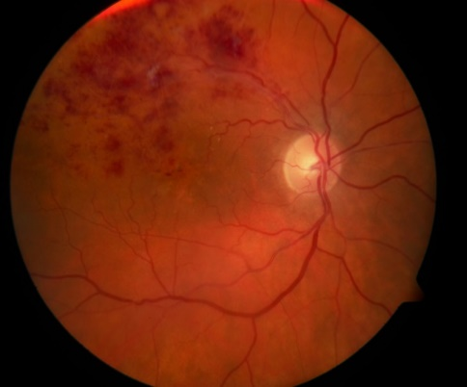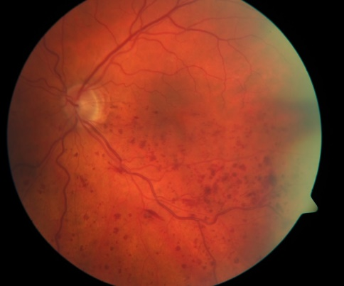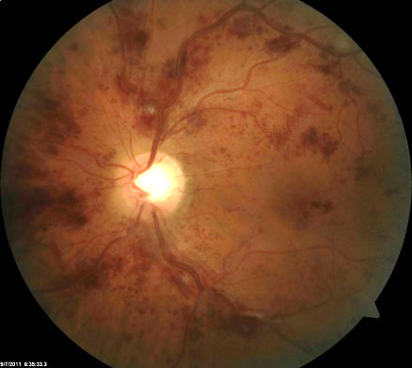

Question 3

Where is the thrombus causing CRVO thought to be located in most cases?
- Anterior to the lamina cribosa
- At the level of the lamina cribosa
- Posterior to the lamina cribosa
- At an arteriovenous crossing

Answer C: Posterior to the lamina cribosa

It is thought that most cases of CRVO are associated with a thrombus just posterior the lamina cribosa, and that in cases with an obstruction at the level of the lamina cribosa there is a tendency for a more complete occlusion (“ischemic” CRVO). This is because occlusion posterior to the lamina cribosa may allow some venous outflow via venous tributaries that occur in the retrocribosal region and anastomose with surrounding veins, producing a less severe (“non-ischemic”) clinical picture.

Reference:

McAllister IL. Central retinal vein occlusion: a review. Clin Experiment Ophthalmol;40(1):48-58.

Question 4

The pathophysiology of most cases of HRVO is thought to be most similar to which of the following?
- CRVO
- BRVO
- CRAO
- BRAO

Answer A: CRVO

While the pathophysiology if HRVO is most comparable to CRVO, HRVO is typically thought of as a form of BRVO in clinical practice and clinical studies.

Multiple anatomic variations in the branching pattern of the CRV exist. In approximately 20% of individuals, the merging of the superior and inferior venous trunks occurs posterior to the lamina cribosa. As such, if one of these trunks is occluded, the clinical picture of a HRVO (affecting either the superior or inferior hemisphere) occurs. A HRVO may also occur if venous outflow from the nasal retina occurs via a branch of the superior or inferior temporal vein rather than an independent nasal vein, and one of these branches is occluded.

References:

Chopdar A. Dual trunk central retinal vein incidence in clinical practice. Arch Ophthalmol 1984;102(1):85-7.

Sanborn GE, Magargal LE. Characteristics of the hemispheric retinal vein occlusion. Ophthalmology 1984;91(12):1616-26.

Question 5

The most common systemic association for RVO in elderly individuals is:
- diabetes mellitus
- dyslipidemia
- systemic inflammatory disease
- hypertension

Answer D: Hypertension

There are multiple risk factors for RVO, many of which correspond to risk factors for generalized atherosclerosis. It should be noted however that generalizing risk factors to all cases RVO can be misleading as certain risk factors are specifically present in certain groups (e.g. age groups, gender, BRVO vs. CRVO, etc.). Major risk factors and other risk factors are discussed below:

Major risk factors:
- Increasing age: The prevalence of RVO is strongly associated with increasing age. The disease is rare before age 50, and up to 5% of individuals over the age of 80 may be affected. Retinal vein occlusion in a young adult warrants thorough investigation for a secondary cause.
- Hypertension: High blood pressure (i.e. >140/>90) is the main risk factor for RVO in those over 50 years of age. It is more strongly associated with BRVO than CRVO. Eyes with signs of hypertensive retinopathy have been shown to have an increased risk of BRVO.
- Dyslipidemia: An abnormality of cholesterol/lipid values (especially high LDL cholesterol) is the main risk factor for RVO in patients less than 50 years of age.
- Glaucoma: Open-angle glaucoma is a risk factor for both CRVO and BRVO. High intraocular pressure compromises venous outflow, and optic nerve cupping may also contribute to mechanical compression of the CRV.

References:

McAllister IL. Central retinal vein occlusion: a review. Clin Experiment Ophthalmol;40(1):48-58.

Laouri M, Chen E, Looman M, Gallagher M. The burden of disease of retinal vein occlusion: review of the literature. Eye (Lond);25(8):981-8.

Marcucci R, Sofi F, Grifoni E, et al. Retinal vein occlusions: a review for the internist. Intern Emerg Med;6(4):307-14.

Hayreh SS, Zimmerman B, McCarthy MJ, Podhajsky P. Systemic diseases associated with various types of retinal vein occlusion. Am J Ophthalmol 2001;131(1):61-77.

Question 6

The most common cause of vision loss following RVO is:
- macular ischemia
- macular edema
- vitreous hemorrhage
- extensive retinal hemorrhages

Answer B: Macular edema

Macular edema is the most common cause of visual loss with RVO. It develops in 5-15% of patients with BRVO within 1 year, and is present (to some degree) in the majority of CRVO cases at initial presentation. Macular edema causes variable decreased and distorted vision. Over the long-term, persistent macular edema may result in alterations of the retinal pigment epithelium (e.g. dispersion and clumping) underneath the fovea with photoreceptor loss. Permanent, profound vision loss with a central scotoma may develop.

The exhibits below show a patient with a superotemporal BRVO and macular edema. The OCT shows both intraretinal and subretinal fluid in the macula area.

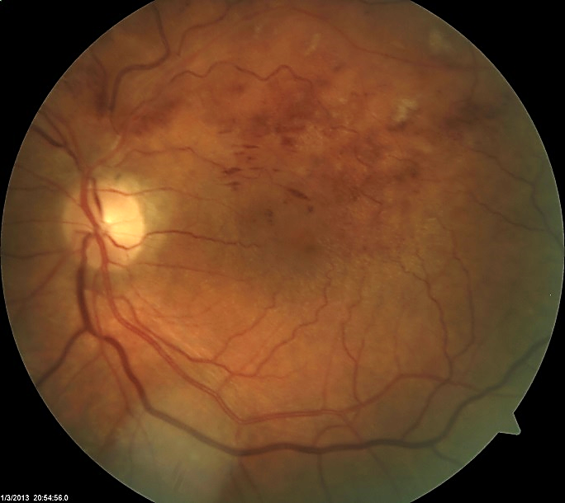

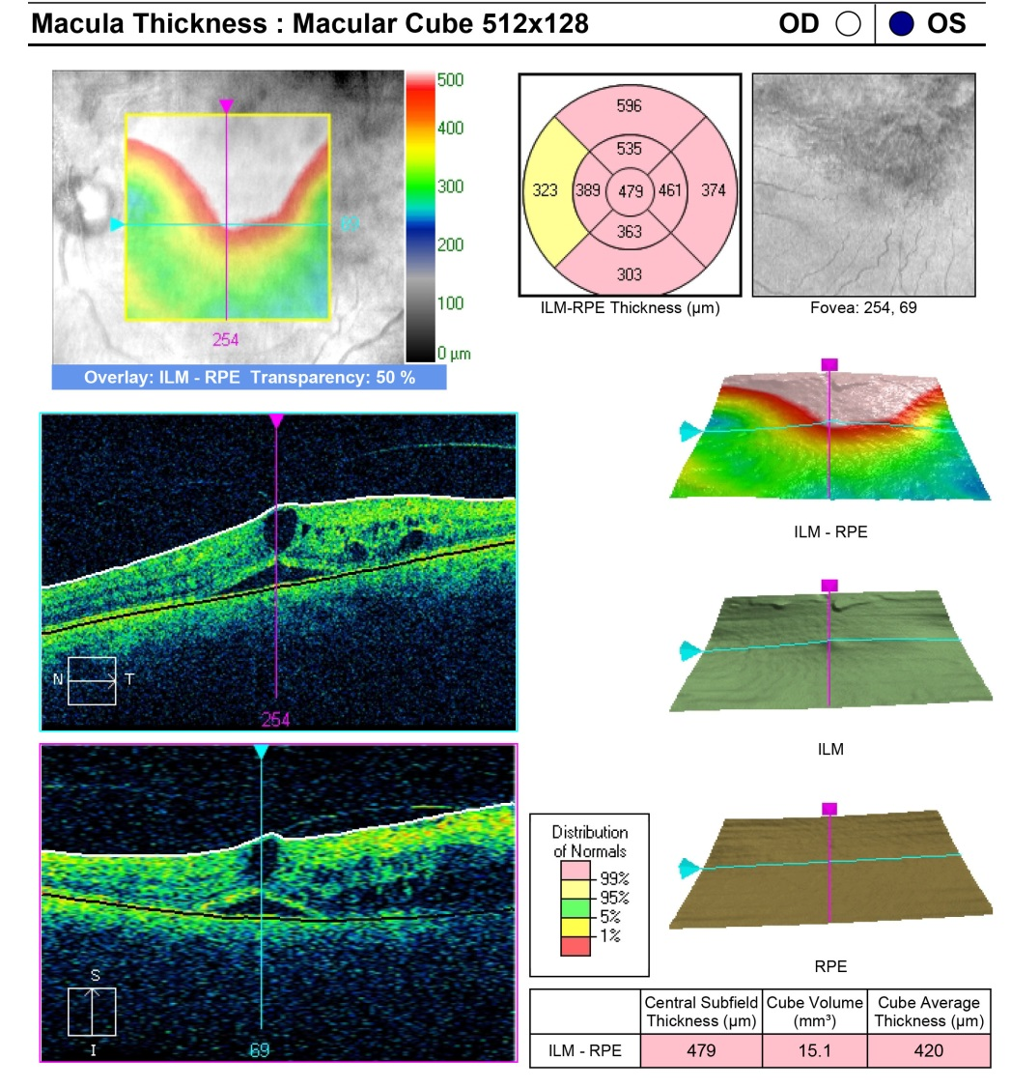

References:

McAllister IL. Central retinal vein occlusion: a review. Clin Experiment Ophthalmol;40(1):48-58.

London NJ, Brown G. Update and review of central retinal vein occlusion. Curr Opin Ophthalmol;22(3):159-65.

Laouri M, Chen E, Looman M, Gallagher M. The burden of disease of retinal vein occlusion: review of the literature. Eye (Lond);25(8):981-8.

Question 7

Which of the following is the most important initiating event for macular edema in CRVO?
- Vitreoretinal traction
- Neovascularization
- Increased intravascular pressure in a closed-loop system
- Low grade chronic inflammation

Answer C: Increased intravascular pressure in a closed-loop system

As the retinal vasculature is a closed-loop system, occlusion of the CRV results in increased intravascular pressure, reduced retinal blood flow, and retinal ischemia. Increased intravascular pressure behind the occlusion may lead to leakage of fluid and small molecules across the vascular wall and into surrounding retinal tissue, resulting in local edema. Often this accumulates in the macular region, causing macular edema (the most common form of vision loss with RVO). The formation of macular edema may be facilitated by vitreoretinal traction.

In addition, vascular endothelial damage as a result of ischemia and damage during and after occlusion may in turn lead to the production of pro-inflammatory mediators and low-grade, chronic inflammation. Inflammatory mediators that are known to be up-regulated with RVO include prostaglandins, leukotrienes, TNF-alpha, vascular endothelial growth factor (VEGF), intracellular adhesion molecule-1 (ICAM-1), and integrins (VEGF is thought to be a prime mediator following RVO and its levels have been correlated with retinal ischemia, neovascularization, and increased severity of macular edema). These cytokines further weaken the blood-retinal barrier, perpetuating the formation of macular edema, and contribute to the development of neovascularization. Chronic low-grade inflammation also promotes oxidative stress and apoptosis which facilitates ongoing macular edema.

References:

Ehlers JP, Fekrat S. Retinal vein occlusion: beyond the acute event. Surv Ophthalmol;56(4):281-99.

Funk M, Kriechbaum K, Prager F, et al. Intraocular concentrations of growth factors and cytokines in retinal vein occlusion and the effect of therapy with bevacizumab. Invest Ophthalmol Vis Sci 2009;50(3):1025-32.

Noma H, Funatsu H, Mimura T, et al. Vitreous levels of interleukin-6 and vascular endothelial growth factor in macular edema with central retinal vein occlusion. Ophthalmology 2009;116(1):87-93.

London NJ, Brown G. Update and review of central retinal vein occlusion. Curr Opin Ophthalmol;22(3):159-65.

Noma H, Funatsu H, Yamasaki M, et al. Aqueous humour levels of cytokines are correlated to vitreous levels and severity of macular oedema in branch retinal vein occlusion. Eye (Lond) 2008;22(1):42-8.

Question 8

BRVO usually occurs at which of the following locations?
- At the margin of the optic disc
- In the far periphery of the retina
- At the level of the lamina cribosa
- At an arteriovenous crossing site

Answer D: At an arteriovenous crossing site

As opposed to CRVO, the occlusion site for a BRVO almost always occurs at an arteriovenous crossing site where the adventitia of artery and vein are fused. This may occur in a quadrant of the retina, portion of the macula, or section of the retinal periphery. Usually sites at which a BRVO have occurred have a configuration in which the artery is anterior to the vein.

The key inciting factors for BRVO are retinal vein compression and damage to the vessel wall, both of which create an environment favorable for thrombus formation. Venous compression (often by a thickened atherosclerotic artery) causes venous narrowing and subsequent turbulent blood flow. This in turn results in damage to the endothelium and subsequent thrombus formation. As with a CRVO, concurrent inflammatory (e.g. vasculitis in which there is damage to the vessel wall) or thrombophilic conditions may further worsen the effects of arterial compression on venous endothelial damage and make conditions favorable for thrombus formation.

References:

Duker JS, Brown GC. Anterior location of the crossing artery in branch retinal vein obstruction. Arch Ophthalmol 1989;107(7):998-1000.

Yilmaz T, Cordero-Coma M. Use of bevacizumab for macular edema secondary to branch retinal vein occlusion: a systematic review. Graefes Arch Clin Exp Ophthalmol;250(6):787-93.

Weinberg D, Dodwell DG, Fern SA. Anatomy of arteriovenous crossings in branch retinal vein occlusion. Am J Ophthalmol 1990;109(3):298-302.

Kiire CA, Chong NV. Managing retinal vein occlusion. Bmj;344:e499.

Kumar B, Yu DY, Morgan WH, et al. The distribution of angioarchitectural changes within the vicinity of the arteriovenous crossing in branch retinal vein occlusion. Ophthalmology 1998;105(3):424-7.

Question 9

Neovascular glaucoma is most common following:

- CRVO
- HRVO
- BRVO
- BRAO

Answer A: CRVO

Neovascular glaucoma is a devastating ocular complication that is not uncommon following RVO, particularly in cases of CRVO with extensive ischemia. The risk of neovascular glaucoma with untreated ischemic CRVO is 40% over 1 year. Neovascular glaucoma is rare in cases of BRVO, even with ischemia and neovascularization.

Reference:

Hayreh SS, Rojas P, Podhajsky P, et al. Ocular neovascularization with retinal vascular occlusion-III. Incidence of ocular neovascularization with retinal vein occlusion. Ophthalmology 1983;90(5):488-506.

Question 10

The natural history of BRVO is to:
- worsen over time
- remain stable
- improve over time to usually 20/20
- improve over time but rarely better than 20/40

Answer D: improve over time but rarely better than 20/40

The natural history (i.e. untreated course) of RVO varies considerably. With a BRVO, visual acuity generally improves over time but usually not to better than 20/40. For patients with macular edema secondary to BRVO, 18-40% of cases resolve over time.

References:

Rogers SL, McIntosh RL, Lim L, et al. Natural history of branch retinal vein occlusion: an evidence-based systematic review. Ophthalmology;117(6):1094-101 e5.

Laouri M, Chen E, Looman M, Gallagher M. The burden of disease of retinal vein occlusion: review of the literature. Eye (Lond);25(8):981-8.

Question 11

In a patient with a RVO, which of the following is the most likely cause of floaters?
- Rhegmatogenous retinal detachment
- Vitreous hemorrhage secondary to neovascularization
- Vitreous hemorrhage secondary to a torn retinal vessel
- Vitreous inflammation

Answer B: Vitreous hemorrhage secondary to neovascularization

Retinal neovascularization may develop in cases of RVO associated with extensive ischemia, which appears as capillary nonperfusion on fluorescein angiography. Neovascularization is more common with CRVO than BRVO and often occurs in the anterior segment without posterior segment neovascularization. It is most likely to develop within the first few months after an occlusion, but may occur years later. Neovascularization may lead to vision-threatening sequelae such as vitreous hemorrhage, tractional retinal detachment, and neovascular glaucoma.

Reference:

Argon laser scatter photocoagulation for prevention of neovascularization and vitreous hemorrhage in branch vein occlusion. A randomized clinical trial. Branch Vein Occlusion Study Group. Arch Ophthalmol 1986;104(1):34-41.

Question 12

How can retinochoroidal collateral vessels be differentiated from neovascularization?
- Collateral vessels leak on IVFA
- Collateral vessels appear finer and grow into the vitreous
- Collateral vessels develop within weeks of RVO
- Collateral vessels appear as tortuous loops and do not leak on IVFA

Answer D: Collateral vessels appear as tortuous loops and do not leak on IVFA

In cases of long-standing vascular obstruction, collateral vessels (retinochoroidal collaterals) may develop which link the retinal venous system to the choroidal venous system. They are often seen at the optic nerve head as tortuous loops following CRVO. It is important to differentiate collaterals from optic disc neovascularization. Neovascularization appears as a very fine, lacy frond of neovascular tissue and is rare with RVO. Collateral vessels are larger and more cork-screw like in nature and do not leak on fluorescein angiogram, contrasting with neovascularization. Collateral vessels are generally seen as a positive prognostic sign indicating compensatory perfusion.

In the exhibit below, prominent retinochoroidal collateral vessels are seen inferior on the disc. This patient presented with a CRVO 8 months ago and now has near-complete resolution of retinal hemorrhages.

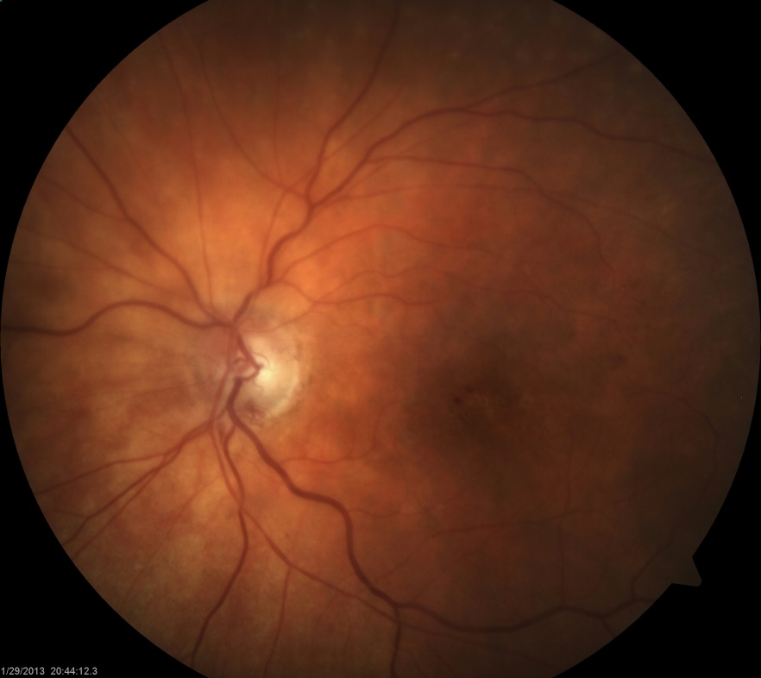

References:

Marcucci R, Sofi F, Grifoni E, et al. Retinal vein occlusions: a review for the internist. Intern Emerg Med;6(4):307-14.

London NJ, Brown G. Update and review of central retinal vein occlusion. Curr Opin Ophthalmol;22(3):159-65.

Question 13

Which of the following is NOT a feature of an ischemic CRVO?
- Visual acuity of 20/80
- Relative afferent pupillary defect
- Extensive capillary nonperfusion on IVFA
- Cotton wool spots

Answer A: Visual acuity of 20/80

Central retinal vein occlusion may be divided by the level of severity or “ischemia”, a classification that is useful from both a prognostic and treatment perspective. Milder cases of CRVO, (formerly known as “venous stasis retinopathy”) tend to have less hemorrhaging and a lack of cotton wool spots, and are termed non-ischemic CRVOs. On the other hand, more severe cases are associated with increased retinal ischemia and are termed ischemic CRVOs. The true distinction between a non-ischemic and ischemic CRVO is based on angiographic findings of the degree of capillary non-perfusion. However, multiple clinical features may be used to help differentiate an ischemic from non-ischemic CRVO.

Clinical features associated with an ischemic CRVO include:
- Poor visual acuity: usually less than 20/200 (and as severe as no light perception).
- Relative afferent pupillary defect
- Significant central visual field defect
- Extensive retinal hemorrhages
- Cotton wool spots
- Reduced b wave amplitude on electroretinography

Reference:

McIntosh RL, Rogers SL, Lim L, et al. Natural history of central retinal vein occlusion: an evidence-based systematic review. Ophthalmology;117(6):1113-23 e15.

Question 14

The natural history of CRVO is to:
- worsen over time
- remain stable
- improve over time to usually 20/20
- improve over time but rarely better than 20/40

Answer A: Worsen over time

In contrast to the spontaneous improvement in visual acuity seen with BRVO, most untreated cases of CRVO result in deterioration of visual acuity over time. This is especially the case for patients with poor baseline visual acuity and significant ischemia. The prognostic significance of poor baseline visual acuity was illustrated in the Central Vein Occlusion Study (CVOS), in which 726 patients presenting with a CRVO of less than 12 months duration were followed for 3 years (note that this is prior to the anti-VEGF era). Briefly, results showed:
- For patients with initial good visual acuity (20/40 or better), 65% of patients maintained this level of acuity over 3 years.
- For those with intermediate baseline vision (20/50 to 20/200), visual acuity improved to better than 20/50 in 19% of patients, stayed within the same range in 44% of patients, and deteriorated to less than 20/200 in 37% of patients.
- For patients presenting with poor visual acuity of less than 20/200, the likelihood of acuity staying below 20/200 was 80%.

It should be noted that for patients with good initial acuity, a significant proportion (35%) still experience significant visual decline over time, which was as severe as 20/200 in 10% of patients.

References:

Natural history and clinical management of central retinal vein occlusion. The Central Vein Occlusion Study Group. Arch Ophthalmol 1997;115(4):486-91.

Baseline and early natural history report. The Central Vein Occlusion Study. Arch Ophthalmol 1993;111(8):1087-95.

Question 15

Which of the following regarding fluorescein angiographic findings of CRVO is INCORRECT?
- Choroidal filling time is delayed
- Retinal vascular filling time is delayed
- Macular edema is seen as late leakage of dye in the macula
- Capillary nonperfusion is readily seen with IVFA

Answer A: Choroidal filling time is delayed

Intravenous fluorescein angiography (IVFA) is critical in the initial work-up of RVO. Findings of RVO on IVFA include:
- Normal choroidal filling: The choroidal vascular systems is unaffected.
- Variable delay in retinal vascular filling: Because the vascular system is normally a closed-loop system, distal obstruction to venous outflow usually causes a vascular filling defect on IVFA.
- Late phase findings: During the late phases of IVFA there is typically variable staining of the optic nerve head and retinal veins along with varying degrees of vascular leakage (especially in the macula) and capillary nonperfusion. Capillary nonperfusion may be extensive in severe or “ischemic” cases.

The distinction between ischemic vs. non-ischemic RVO is defined based on the degree of capillary nonperfusion and defined by criteria in the CVOS and BVOS studies:
- CRVO: a CRVO is considered ischemic with at least 10 disc areas of capillary nonperfusion on fluorescein angiography.
- BRVO: a BRVO is considered ischemic with at least 5 disc areas of capillary nonperfusion are present. This distinction is used less frequently than with a CRVO.

The exhibits below show IVFA findings on a patient with a superotemporal BRVO. Note the delayed venous filling in the area of the BRVO, along with areas of capillary nonperfusion during the mid-AV phase on the left. The exhibit on the right is the late phase of IVFA showing extensive leakage of dye.

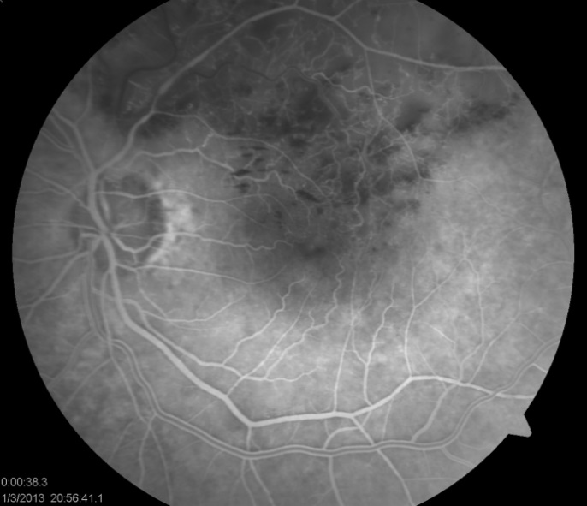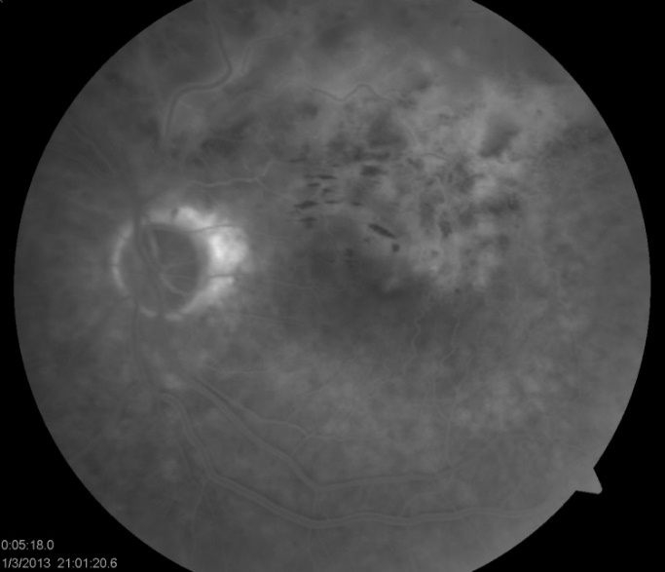

References:

Baseline and early natural history report. The Central Vein Occlusion Study. Arch Ophthalmol 1993;111(8):1087-95.

Kiire CA, Chong NV. Managing retinal vein occlusion. Bmj;344:e499.

McAllister IL. Central retinal vein occlusion: a review. Clin Experiment Ophthalmol;40(1):48-58.

Question 16

What does “indeterminate” refer to in relation to an ischemic vs. non-ischemic CRVO?
- There are exactly 10 disc areas of capillary nonperfusion
- The IVFA frames were of insufficient quality to be read
- Extensive hemorrhaging makes assessment of capillary nonperfusion difficult
- The patient had an anaphylactic reaction during IVFA which required discontinuation

Answer C: Extensive hemorrhaging makes assessment of capillary nonperfusion difficult

The distinction between ischemic and non-ischemic CRVO is important as the risk of neovascularization is significant with ischemic CRVOs. It should be noted that in some cases (e.g. with extensive retinal hemorrhage) this distinction cannot be made, with the terminology of “indeterminate” often being used. Approximately 1/3 of initially non-ischemic CRVOs will convert to ischemic within a 3 year period, most within the first 4 months.

References:

Lattanzio R, Torres Gimeno A, Battaglia Parodi M, Bandello F. Retinal vein occlusion: current treatment. Ophthalmologica;225(3):135-43.

Hayreh SS, Klugman MR, Beri M, et al. Differentiation of ischemic from non-ischemic central retinal vein occlusion during the early acute phase. Graefes Arch Clin Exp Ophthalmol 1990;228(3):201-17.

Natural history and clinical management of central retinal vein occlusion. The Central Vein Occlusion Study Group. Arch Ophthalmol 1997;115(4):486-91.

Question 17

At what frequency should a patient with an ischemic CRVO be assessed during the first 6 months?
- Weekly
- Biweekly
- Monthly
- Every 2 months

Answer C: Monthly

All cases of RVO require follow-up to monitor for visual change and vision-threatening sequelae such as macular edema and neovascularization. General follow-up guidelines include:
- Ischemic or indeterminate CRVOs are at high risk of neovascularization and should be followed monthly for at least 6 months. An undilated slit-lamp examination and gonioscopy to screen for anterior segment neovascularization should be performed at each visit. Scatter laser photocoagulation should be started promptly if neovascularization develops.
- Patients with non-ischemic CRVO with good visual acuity (e.g. better than 20/40) can be seen every 2 months for at least 6 months, then yearly.
- Patients with intermediate visual acuity of 20/60-20/200 should also be seen monthly for at least 6 months, increasing the interval between visits on a case by case basis.

Reference:
London NJ, Brown G. Update and review of central retinal vein occlusion. Curr Opin Ophthalmol;22(3):159-65.

Question 18

Which of the following patients would warrant the most extensive systemic workup following a RVO?
- 30-year-old female with no pertinent medical history
- 80-year-old male with no history of hypertension
- 85-year-old female with hypertension and a history of RVO 3 years prior
- 65-year-old male on aspirin

Answer A: 30-year-old female with no medical history

The occurrence of a RVO in any patient warrants some degree of systemic workup. While many cases in elderly individuals occur in the presence of atherosclerotic risk factors and require minimal investigation, cases in younger patients (especially less than 50) warrant a more thorough investigation. The purpose of a systemic workup is to identify, treat, and optimize underlying medical conditions such as diabetes and hypertension to prevent non-ocular organ damage as well as the recurrence of a RVO. The occurrence of a RVO should be clearly communicated to the general practitioner so that he/she can take part in a systemic evaluation and assist in counselling the patient about risk factors.

The recommendations on what constitutes a primary work-up for patients with RVO varies considerably but typically includes the following elements:
- Full blood count: quantifies concentration of red blood cells, white blood cells, and platelets in the blood.
- Erythrocyte sedimentation rate or C reactive protein: non-specific markers of inflammation
- Markers for kidney dysfunction: e.g. electrolytes, urea, creatinine.
- Random blood glucose/oral glucose tolerance test: screen for diabetes mellitus.
- Cholesterol/lipid levels: screen for dyslipidemia.
- Electrocardiogram

Other tests which may be ordered at the discretion of the clinician include:
- Serum protein electrophoresis: screen for myelodysplastic conditions such as multiple myeloma.
- Thyroid function
- Echocardiogram: ultrasound investigation of cardiac function.
- Carotid and vertebral artery Doppler scans
- Fasting homocysteine levels: recall relationship between hyperhomocysteinemia and RVO.
- Chest X-ray
- Serum autoantibodies: if there is suspicion of systemic autoimmune condition (e.g. rheumatoid factor, antinuclear antibodies, anti-DNA antibodies, antineutrophilic cytoplasmic antibodies)
- Thrombophilia screen: Thrombophilia screening should be considered in young patients, those with bilateral RVO, a history of previous thrombosis, or family history of thrombosis. A complete thrombophilia screen might include protein S, protein C, prothrombin gene mutation, antithrombin III, anticardiolipin antibody, activated protein C resistance, and lupus anticoagulant.

As discussed, the strongest risk factor for RVO, especially in elderly individuals, is hypertension. This should be clearly communicated to the primary care physician so that blood pressure can be optimized (i.e. <140 systolic and <90 diastolic, or lower targets if diabetic). Concurrent diabetes mellitus should be well controlled as well.

References:

Marcucci R, Sofi F, Grifoni E, et al. Retinal vein occlusions: a review for the internist. Intern Emerg Med;6(4):307-14.

Kiire CA, Chong NV. Managing retinal vein occlusion. Bmj;344:e499.

Wong TY, Scott IU. Clinical practice. Retinal-vein occlusion. N Engl J Med;363(22):2135-44.

Yau JW, Lee P, Wong TY, et al. Retinal vein occlusion: an approach to diagnosis, systemic risk factors and management. Intern Med J 2008;38(12):904-10.

Question 19

What recommendations would you give a family doctor (in addition to conducting a systemic workup) if a 40-year-old female on oral contraceptive therapy develops a RVO?

- Consider discontinuation of oral contraception
- Current use of oral contraception may be continued
- Change to intramuscular form of oral contraception
- If oral contraception is continued, concurrent aspirin therapy is recommended

Answer A: Consider discontinuation of oral contraception

Use of oral contraception should be inquired as this is the most common underlying association in young females with retinal vein occlusions. Females under age 50 who present with RVOs should be questioned about oral contraception use, as this is an important risk factor in this demographic.

Oral contraception should be prescribed with extreme caution in women with a history of RVO. Estrogen hormone replacement therapy is also relatively contraindicated in women with a history of RVO.

Reference:

Kiire CA, Chong NV. Managing retinal vein occlusion. Bmj;344:e499.

Question 20

Dehydration is a risk factor for RVO because it:

- causes a release of inflammatory mediators
- directly damages the endothelium of blood vessels
- causes an increase in blood viscosity
- increases the concentration of electrolytes in the blood

Answer C: Causes an increase in blood viscosity

Dehydration increases blood viscosity and may increase risk of RVO by altering hemodynamics. Dehydration is a not uncommon cause of CRVO in younger patients. Myeloproliferative diseases, such as multiple myeloma and polycythemia vera, also increase blood viscosity and increase the risk of RVO.

Reference:

Kiire CA, Chong NV. Managing retinal vein occlusion. Bmj;344:e499.

Question 21

Which of the following statements best describes the indication for aspirin in RVO?

- Indicated if extensive hemorrhaging present
- Indicated if macular edema present
- Indicated if macular ischemia present
- Not indicated specifically for RVO

Answer D: Not indicated specifically for RVO

Aspirin (and other anticoagulants) have little, if any, role in the acute management of RVO. Aspirin not only doesn’t target the key inciting events for RVO (i.e. compression of vein by artery), but it also may worsen hemorrhaging. Even over the long-term, aspirin is not recommended for the primary prevention of cardiovascular events in patients with RVO. General guidelines are that aspirin is indicated only when the 10-year risk of coronary heart disease is >15% or the 10-year risk of total cardiovascular disease is >20% (calculated according to the Framingham calculator), providing blood pressure control is satisfactory and there are no contraindications (e.g. stomach ulcers, allergy, history of major bleeding). Aspirin should be avoided in the initial stages of a severe hemorrhagic RVO.

Reference:

Kiire CA, Chong NV. Managing retinal vein occlusion. Bmj;344:e499.

Question 22

Which of the following describes the correlation between central foveal thickness and visual acuity in cases of RVO?

- Positive correlation
- No correlation
- Negative correlation

Answer C: Negative correlation

Optical coherence tomography (OCT) of the macula is a commonly-used diagnostic test to screen for and quantify the degree of macular edema. With macular edema, OCT shows cystic fluid-filled spaces in the macula with retinal thickening and occasionally submacular fluid. The macular thickness on OCT has been shown to inversely correlate with visual acuity, and is often used as a marker of response to therapy.

The exhibit below shows a patient with an inferior HRVO. Note the presence of macular edema in the inferior macula, corresponding to the increase in retinal thickening.

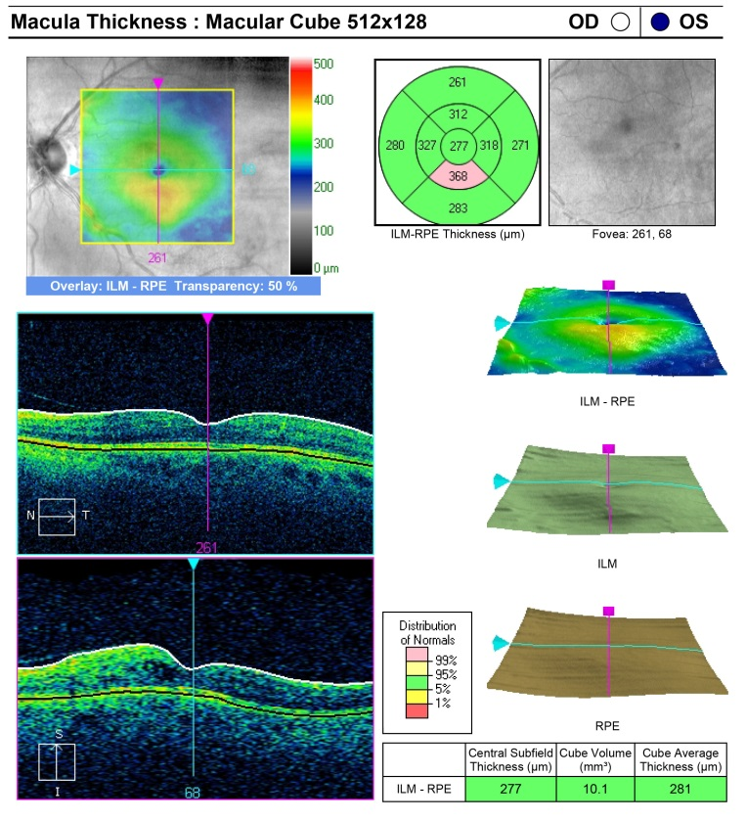

References:

McAllister IL. Central retinal vein occlusion: a review. Clin Experiment Ophthalmol;40(1):48-58.

Martinet V, Guigui B, Glacet-Bernard A, et al. Macular edema in central retinal vein occlusion: correlation between optical coherence tomography, angiography and visual acuity. Int Ophthalmol;32(4):369-77.

Question 23

Which of the following statements best describes the results of the Central Vein Occlusion Study (CVOS) related to macular edema?

- Macular laser photocoagulation did not show a visual benefit compared to observation in the treatment of macular edema
- Macular laser photocoagulation resulted in a significant visual benefit over observation in the treatment of macular edema
- Macular edema is rare after CRVO
- Triamcinolone is an effective therapy for macular edema

Answer A: Macular laser photocoagulation did not show a visual benefit compared to observation in the treatment of macular edema

Treatments for RVO are generally geared towards either the etiology of occlusion itself, or the sequelae of occlusion, mainly macular edema and neovascularization. Traditionally, the gold-standard treatment for RVO has been laser photocoagulation (based on results of the CVOS and BVOS); however, today the first-line treatment is generally with anti-VEGF treatments with a secondary role for other treatments such as laser photocoagulation, corticosteroids, and experimental/investigational treatments.

The efficacy of macular laser photocoagulation was best studied in two pivotal trials in the 1980s, the Branch Vein Occlusion Study (BVOS) and the Central Vein Occlusion Study (CVOS). The CVOS investigated the effectiveness of macular laser photocoagulation in treating patients with macular edema secondary to CRVO. Patients with perfused macular edema and visual acuity 20/50 or worse were randomized to laser photocoagulation or observation. While a small, statistically-significant decrease in macular thickness was seen with the use of photocoagulation, no benefit was seen in terms of visual acuity. Because of these findings macular laser photocoagulation is not recommended in patients with macular edema secondary to CRVO.

References:

Baseline and early natural history report. The Central Vein Occlusion Study. Arch Ophthalmol 1993;111(8):1087-95.

Martinet V, Guigui B, Glacet-Bernard A, et al. Macular edema in central retinal vein occlusion: correlation between optical coherence tomography, angiography and visual acuity. Int Ophthalmol;32(4):369-77.

Question 24

Which best describes the results of the Branch Vein Occlusion Study (BVOS) related to macular edema?

- Macular laser photocoagulation did not show a visual benefit compared to observation in the treatment of macular edema
- Macular laser photocoagulation resulted in a significant visual benefit over observation in the treatment of macular edema
- Scatter laser photocoagulation provides a significant improvement in macular edema.
- Triamcinolone is an effective therapy for macular edema

Answer B: Macular laser photocoagulation resulted in a significant visual benefit over observation in the treatment of macular edema

In the BVOS, patients with BRVO and visual acuity 20/40 to 20/200 due to perfused macular edema (i.e. absence of macular ischemia) were randomized to either grid-pattern photocoagulation or no treatment. The % of patients gaining at least 2 lines of vision from baseline was higher in the laser group compared to control group (65 vs. 37%). The BVOS also showed that while patients treated within 12 months of onset had a better response to therapy, small benefits were still seen in patients after 12 months from onset. Patients with severe vision loss (i.e. <20/200) were unlikely to benefit from laser.

The BVOS concluded that macular laser photocoagulation is indicated for macular edema persisting longer than 3 months without spontaneous improvement and visual acuity in the range of 20/40 to 20/200. Waiting 3-6 months after the initial event allows absorption of hemorrhage and the opportunity for spontaneous improvement.

The BVOS also evaluated the effectiveness of prophylactic scatter laser photocoagulation (panretinal photocoagulation) in preventing subsequent neovascularization and vitreous hemorrhage in patients with significant retinal ischemia. Laser resulted in a decreased incidence of neovascularization, however many patients in the observation group did not go on to develop neovascularization. Scatter laser was also effective at treating neovascularization when it did develop, and the likelihood of vitreous hemorrhage when neovascularization did appear was higher in the prophylactic laser group compared to the observation group. Based on these results, the BVOS recommended that laser photocoagulation be deferred until neovascularization is present.

References:

Argon laser scatter photocoagulation for prevention of neovascularization and vitreous hemorrhage in branch vein occlusion. A randomized clinical trial. Branch Vein Occlusion Study Group. Arch Ophthalmol 1986;104(1):34-41.

Argon laser photocoagulation for macular edema in branch vein occlusion. The Branch Vein Occlusion Study Group. Am J Ophthalmol 1984;98(3):271-82.

Shilling JS, Jones CA. Retinal branch vein occlusion: a study of argon laser photocoagulation in the treatment of macular oedema. Br J Ophthalmol 1984;68(3):196-8.

Question 25

When should scatter laser photocoagulation be initiated in cases of ischemic CRVO?

- At the time of diagnosis of CRVO
- 3 months after the onset of visual loss
- Promptly when neovascularization develops
- Not until pressure is elevated as a result of neovascular glaucoma

Answer C: Promptly when neovascularization develops

The CVOS recommended that eyes with CRVO at high risk of neovascularization should not have prophylactic laser but rather be followed monthly for 6-8 months, with prompt scatter laser photocoagulation if neovascularization appears. High risk features include large areas of capillary nonperfusion, recent onset (i.e. <1 month), and visual acuity <20/200.

The recommendation against prophylactic panretinal photocoagulation laser resulted from the findings that prophylactic treatment decreased but did not eliminate the risk of anterior segment neovascularization and that patients without previous prophylactic laser had great resolution of anterior segment neovascularization than those who had the prophylactic laser.

Reference:

A randomized clinical trial of early panretinal photocoagulation for ischemic central vein occlusion. The Central Vein Occlusion Study Group N report. Ophthalmology 1995;102(10):1434-44.

Question 26

Which statement best describes results of the CRUISE trial?

- Anti-VEGF therapy was superior to macular laser photocoagulation in treatment of macular edema secondary to CRVO
- Anti-VEGF therapy was superior to triamcinolone
- VEGF-trap agents demonstrated excellent efficacy and safety
- Anti-VEGF therapy was superior to observation in treatment of macular edema secondary to CRVO

Answer D: Anti-VEGF therapy was superior to observation in treatment of macular edema secondary to CRVO

Vascular endothelial growth factor (VEGF) is a key mediator in the pathophysiology of macular edema and neovascular complications of RVO. The advent of VEGF inhibitors has significantly changed treatment paradigms for RVO, and with phase III clinical trials demonstrating excellent efficacy and acceptable safety profiles these agents are now first line treatment for RVO.

The efficacy of anti-VEGF therapy (specifically ranibizumab) in the treatment of macular edema secondary to BRVO and CRVO has been demonstrated in 2 large phase III clinical trials, the BRAVO and CRUISE studies. Both the BRAVO and CRUISE studies showed significant visual improvements and decreased macular thickness on OCT associated with ranibizumab injections over the 12 month study period. In the CRUISE study, nearly half of all patients who received intravitreal ranibizumab had a 3 line or more improvement in vision, as compared to only 17.9% of controls.

Reference:

Pe'er J, Folberg R, Itin A, et al. Vascular endothelial growth factor upregulation in human central retinal vein occlusion. Ophthalmology 1998;105(3):412-6.

Question 27

Which statement best describes the role of anti-VEGF therapy with neovascular glaucoma?

- Short-term use as an adjunct to retinal ablation and IOP control
- Indefinite monthly injections as a primary therapy
- Indicated only if posterior segment neovascularization present
- No indication for anti-VEGF with neovascular glaucoma

Answer A: Short-term use as an adjunct to retinal ablation and IOP control

Anti-VEGF agents are frequently used to treat neovascular disorders of the eye, and provide rapid regression of anterior and posterior segment neovascularization such as with RVO. However, their efficacy is short-lived. As such, their use in the setting of neovascularization is as an adjunctive role to retinal ablative procedures and IOP treatment.

Question 28

Which of the following VEGF inhibitors is a full length monoclonal antibody directed against all forms of VEGF?
- Pegaptanib (Macugen)
- Bevacizumab (Avastin)
- Ranibizumab (Lucentis)
- Afibercept (Eylea)

Answer B: Bevacizumab (Avastin)

The most commonly used anti-VEGF agents with RVO are the monoclonal antibodies bevacizumab and ranibizumab. While bevacizumab is a full-length humanized monoclonal antibody directed against all biologically active forms of VEGF, ranibizumab consist of only the Fab component and is FDA-approved for intraocular use (while bevacizumab use remains “off label”).

While slightly different structurally, bevacizumab is thought to have a similar efficacy profile compared to ranibizumab. Bevacizumab use with RVO has been studied in small nonrandomized studies showing short-term beneficial effects on visual acuity and resolution of macular edema. Like ranibizumab, its effect lasts 4-6 weeks with repeated injections necessary.

While bevacizumab and ranibizumab compromise the majority of anti-VEGF use with RVO, a new medication called afibercept (Eylea) has been developed which will likely be used more in the future. Afibercept is a “VEGF trap” molecule that fuses to VEGF, impairing its function.

References:

Kriechbaum K, Michels S, Prager F, et al. Intravitreal Avastin for macular oedema secondary to retinal vein occlusion: a prospective study. Br J Ophthalmol 2008;92(4):518-22.

Rosenfeld PJ, Fung AE, Puliafito CA. Optical coherence tomography findings after an intravitreal injection of bevacizumab (avastin) for macular edema from central retinal vein occlusion. Ophthalmic Surg Lasers Imaging 2005;36(4):336-9.

Iturralde D, Spaide RF, Meyerle CB, et al. Intravitreal bevacizumab (Avastin) treatment of macular edema in central retinal vein occlusion: a short-term study. Retina 2006;26(3):279-84.

Costa RA, Jorge R, Calucci D, et al. Intravitreal bevacizumab (avastin) for central and hemicentral retinal vein occlusions: IBeVO study. Retina 2007;27(2):141-9.

Manousaridis K, Talks J. Macular ischaemia: a contraindication for anti-VEGF treatment in retinal vascular disease? Br J Ophthalmol;96(2):179-84.

Brown DM, Heier JS, Clark WL, et al. Intravitreal Aflibercept Injection for Macular Edema Secondary to Central Retinal Vein Occlusion: 1-Year Results From the Phase 3 COPERNICUS Study. Am J Ophthalmol.

Question 29

Which of the following surgical procedures is most appropriate for IOP control in a blind painful eye secondary to neovascular glaucoma?
- Trabeculectomy with mitomycin C
- Enucleation
- Cyclodestructive procedure
- Peripheral iridotomy

Answer C: Cyclodestructive procedure

Patients with neovascular glaucoma typically present with pain and loss of vision. Neovascularization of the iris (rubeosis) and angle may be seen, and in time the angle can completely close off as fibrovascular tissue contracts.

Treatment of neovascular glaucoma consists of IOP control and retinal ablation (i.e. scatter laser photocoagulation or cryotherapy) under the direction of a glaucoma and retina specialist. Administration of anti-VEGF agents may be of benefit in the short-term. If the eye is completely blind, goals of treatment may shift towards keeping the patient comfortable with topical steroids, atropine, and modest IOP control. Surgery for neovascular glaucoma typically requires a glaucoma drainage device and/or cyclodestructive procedures.

Reference:

Kiire CA, Chong NV. Managing retinal vein occlusion. Bmj;344:e499.

